PRACTICAL – 12
Name: Teja Hasini Reddy
Roll No: 2520030048
Sec: 8

PART 1: PRODUCER-CONSUMER PROBLEM

Aim
To implement the Producer-Consumer problem using counting semaphores and POSIX threads, and evaluate synchronization correctness and system throughput under different buffer sizes.

Theory
The Producer-Consumer problem involves a producer adding items to a shared buffer and a consumer removing them. Counting semaphores ensure that the producer does not add to a full buffer and the consumer does not remove from an empty buffer.

C Code
- include <stdio.h>
- include <pthread.h>
- include <semaphore.h>

- define BUFFER_SIZE 5
- define ITEMS 20

int buffer[BUFFER_SIZE]; int in = 0, out = 0;

sem_t empty, full; pthread_mutex_t mutex;

void *producer(void *arg)
{
for (int i = 1; i <= ITEMS; i++)
{
sem_wait(&empty); pthread_mutex_lock(&mutex);
buffer[in] = i; printf("Produced: %d\n", i); in = (in + 1) % BUFFER_SIZE;

pthread_mutex_unlock(&mutex);

sem_post(&full);
}

return NULL;
}

void *consumer(void *arg)
{
for (int i = 1; i <= ITEMS; i++)
{
sem_wait(&full);

pthread_mutex_lock(&mutex);

int item = buffer[out]; printf("Consumed: %d\n", item); out = (out + 1) % BUFFER_SIZE;

pthread_mutex_unlock(&mutex);

sem_post(&empty);
}

return NULL;
}

int main()
{
pthread_t producer_thread, consumer_thread;

sem_init(&empty, 0, BUFFER_SIZE);
sem_init(&full, 0, 0); pthread_mutex_init(&mutex, NULL);

pthread_create(&producer_thread, NULL, producer, NULL); pthread_create(&consumer_thread, NULL, consumer, NULL);

pthread_join(producer_thread, NULL); pthread_join(consumer_thread, NULL);

sem_destroy(&empty); sem_destroy(&full); pthread_mutex_destroy(&mutex);

return 0;
}
OUTPUT –
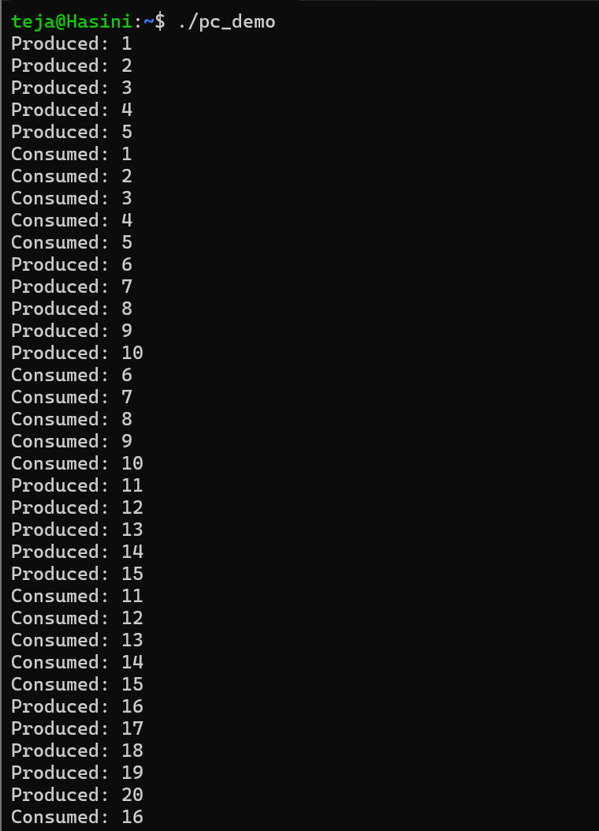

Compile
gcc producer_consumer.c -o pc -pthread

Run
./pc

Flow Chart
START
↓
Initialize Buffer and Semaphores
↓
Create Producer and Consumer
↓
Producer → empty → Add Item
↓
Consumer → full → Remove Item
↓
Mutex Protects Buffer
↓
All Items Processed?
↓
YES
↓
Destroy Semaphores
↓
STOP

Buffer Size Evaluation
Buffer Size | Synchronization | Throughput
2 | Correct | Lower
5 | Correct | Good
10 | Correct | Higher
20 | Correct | Depends on system
Larger buffers can reduce waiting between producer and consumer, but the actual throughput depends on CPU, scheduling, and workload.

OUTPUT:

Result
The Producer-Consumer problem was successfully implemented using POSIX

threads, counting semaphores, and a mutex. Synchronization was maintained correctly and buffer size affected throughput.

PART 2: DEADLOCK AND PREVENTION USING RESOURCE ORDERING

Aim
To design a deadlock scenario involving multiple threads competing for shared resources, demonstrate deadlock occurrence, identify the four necessary conditions for deadlock, and prevent deadlock using resource ordering.

Theory
A deadlock occurs when threads wait indefinitely for resources held by each other.
The four necessary conditions are:
- Mutual Exclusion – A resource can be used by only one thread at a time.
- Hold and Wait – A thread holds one resource while waiting for another.
- No Preemption – A resource cannot be forcibly taken from a thread.
- Circular Wait – Threads form a circular chain of waiting.

Deadlock Code
- include <stdio.h>
- include <pthread.h>
- include <unistd.h>

pthread_mutex_t resource1 = PTHREAD_MUTEX_INITIALIZER; pthread_mutex_t resource2 = PTHREAD_MUTEX_INITIALIZER;

void *thread1(void *arg)
{
pthread_mutex_lock(&resource1); printf("Thread 1 locked Resource 1\n");

sleep(1);

pthread_mutex_lock(&resource2); printf("Thread 1 locked Resource 2\n");

pthread_mutex_unlock(&resource2); pthread_mutex_unlock(&resource1);

return NULL;
}

void *thread2(void *arg)
{
pthread_mutex_lock(&resource2); printf("Thread 2 locked Resource 2\n");

sleep(1);

pthread_mutex_lock(&resource1); printf("Thread 2 locked Resource 1\n");

pthread_mutex_unlock(&resource1); pthread_mutex_unlock(&resource2);

return NULL;
}

int main()
{
pthread_t t1, t2;

pthread_create(&t1, NULL, thread1, NULL); pthread_create(&t2, NULL, thread2, NULL);

pthread_join(t1, NULL); pthread_join(t2, NULL);

return 0;
}

Compile
gcc deadlock.c -o deadlock -pthread

OUTPUT:
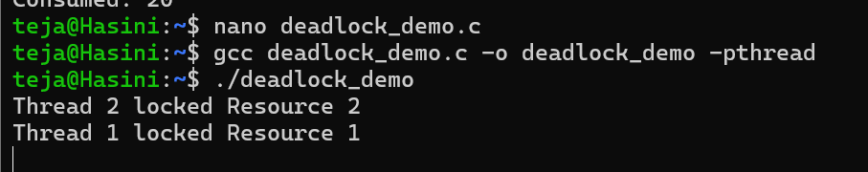

Run
./deadlock
The program may remain stuck because each thread waits for a resource held by the other.

PART 3: DEADLOCK PREVENTION USING RESOURCE ORDERING

Aim
To prevent deadlock by forcing all threads to acquire shared resources in the same order.

C Code
- include <stdio.h>
- include <pthread.h>
- include <unistd.h>

pthread_mutex_t resource1 = PTHREAD_MUTEX_INITIALIZER; pthread_mutex_t resource2 = PTHREAD_MUTEX_INITIALIZER;

void *thread1(void *arg)
{
pthread_mutex_lock(&resource1); printf("Thread 1 locked Resource 1\n");

sleep(1);

pthread_mutex_lock(&resource2); printf("Thread 1 locked Resource 2\n");

pthread_mutex_unlock(&resource2); pthread_mutex_unlock(&resource1);

return NULL;
}

void *thread2(void *arg)
{
/* Same order: Resource 1 first, Resource 2 second */ pthread_mutex_lock(&resource1);
printf("Thread 2 locked Resource 1\n"); sleep(1);
pthread_mutex_lock(&resource2); printf("Thread 2 locked Resource 2\n");

pthread_mutex_unlock(&resource2); pthread_mutex_unlock(&resource1);

return NULL;
}

int main()
{
pthread_t t1, t2;

pthread_create(&t1, NULL, thread1, NULL); pthread_create(&t2, NULL, thread2, NULL);

pthread_join(t1, NULL); pthread_join(t2, NULL);

printf("No deadlock occurred.\n");

return 0;
}

Compile
gcc prevention.c -o prevention -pthread

Run
./prevention

Expected Output
Thread 1 locked Resource 1
Thread 1 locked Resource 2
Thread 2 locked Resource 1
Thread 2 locked Resource 2 No deadlock occurred.

Flow Chart
START
↓
Create Two Resources
↓
Create Multiple Threads
↓
Acquire Resources
↓
Different Order?
↓
YES → DEADLOCK
↓
Apply Resource Ordering
↓
Resource 1 → Resource 2
↓
Threads Complete
↓
STOP

Observation
In the deadlock program, each thread locks one resource and waits for the

other, creating a circular wait. By forcing all threads to acquire resources in the same order, circular wait is eliminated.

OUTPUT:

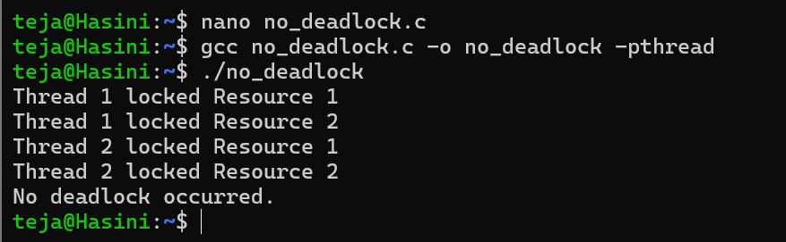

Result
Deadlock was successfully demonstrated and prevented using resource ordering. The prevention strategy eliminates the circular-wait condition and allows all threads to complete successfully.

